* IMMDler üzerine termal anlamda neler yapılmış çıkarmak lazım.
* Heatsink tasarımı ve verimlerinin karşılaştırılmasını IMMD özelinde
* GaN ile ilgili de yine yapılmış çalışmalara bakarak
* termal modelle Loss model

2006

Pickering, S., Thovex, F., Wheeler, P., & Bradley, K. (2006). Thermal Design of an Integrated Motor Drive. *IECON 2006 - 32nd Annual Conference on IEEE Industrial Electronics*, 4794–4799. https://doi.org/10.1109/IECON.2006.348109

* the thermal design of the motor to dissipate the losses from the drive
* Computational fluid dynamics (CFD) was used to model the ventilation and heat transfer from the new end cover and to develop improved fan geometries.

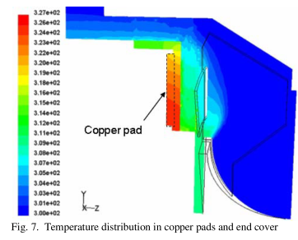

* An improved fan geometry was designed to keep the power electronics cool under high ambient temperatures with the motor running at full load. Mass Flow rate of the fan is calculated.

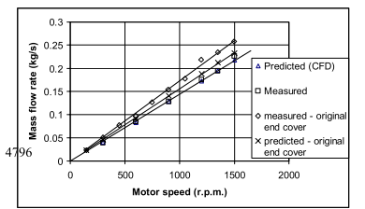

2014

Han, D., Ogale, A., Li, S., Li, Y., & Sarlioglu, B. (2014). Efficiency characterization and thermal study of GaN based 1 kW inverter. *IEEE Applied Power Electronics Conference and Exposition - APEC*, 2344–2350. https://doi.org/10.1109/APEC.2014.6803631

* Loss and efficiency analysis is performed under various load conditions, and the requirements on heat sink for various ambient temperatures are specified according to the loss values obtained. Analysis results are compared with conventional Si-based inverters
* Cooling requirements for the inverter are evaluated for the condition of a zero power factor load when maximum losses (TC4) are obtained in FETs.
* Thermal conductance of a circuit board is calculated

Gth= 1/Rth=A/(ρ1l1+ ρ2l2)=A/( l1/σ1+ l2/σ2)

* The minimum required PCB volume to dissipate the heat generated at given ambient temperature, is chosen as an indicator of the cooling requirements in this paper.

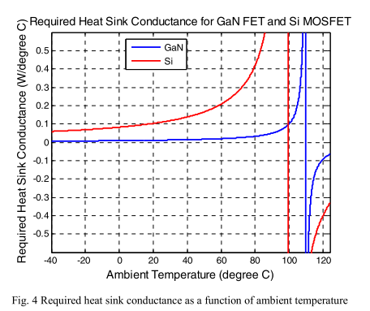

2015

Abebe, R., Vakil, G., Calzo, G. Lo, Cox, T., Gerada, C., & Johnson, M. (2015). FEA Based Thermal Analysis of Various Topologies for Integrated Motor Drives (IMD), (Imd), 1976–1981.

* Investigates existing IMD configurations based on their mounting position around the machine housing.

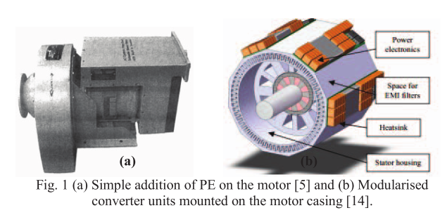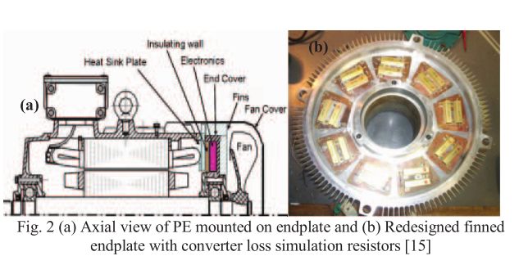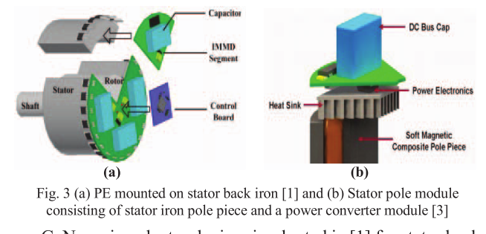

* Thermal analysis of various integration concepts are analysed using FEA (ANSYS). A permanent magnet synchronous motor was modelled. The FE models are developed for each topology.

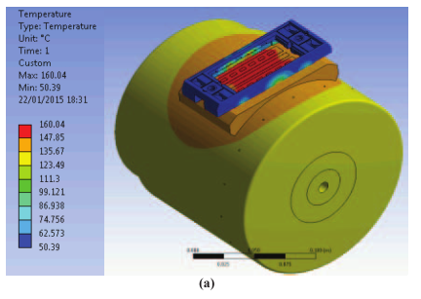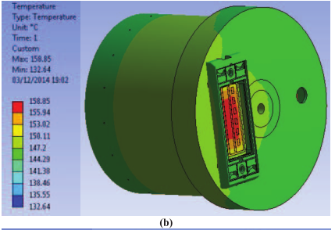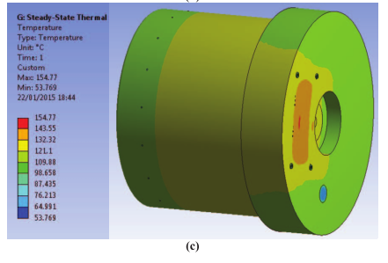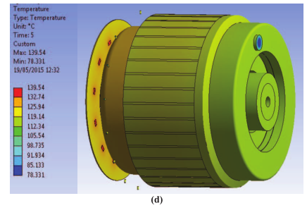

* The advantages and disadvantages of the analysed configurations are also discussed based on the temperature distribution of their individual components.

Zhang, H., & Balog, R. S. (2015). Loss analysis during dead time and thermal study of gallium nitride devices. 2015 IEEE Applied Power Electronics Conference and Exposition (APEC), 737–744. https://doi.org/10.1109/APEC.2015.7104432

* A simplified thermal resistor model of heat transfer is utilized.
* The minimum board size (of PCB) Sb_min for heat dissipation of GaN FETs is calculated

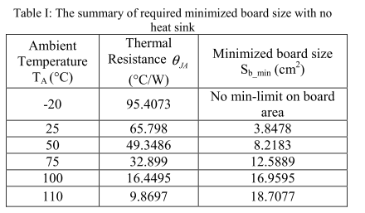

* Loss calculations are done. Then, FEA themal analysis.

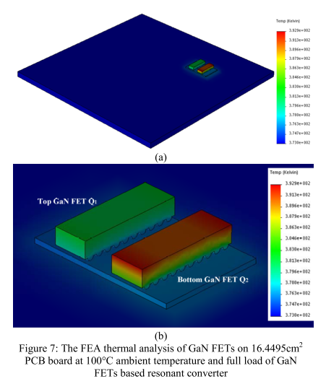

2016

2017